COMP-SCI 456 LAB 2
Phase 1: Network Connectivity & Environment Verification
Before attempting any exploit development, I first verified that reliable network connectivity existed between the Kali Linux attacker VM and the Windows 7 victim VM. This was necessary to confirm that the victim machine was online, reachable at the expected IP address, and capable of communicating with the attacker system. Basic connectivity was tested with ping, which helped verify that the victim operating system was running and that its network interface was active. This step was also important because the intended reverse shell payload would require the victim machine to establish an outbound TCP connection back to the attacker. If the two systems could not communicate at the network level, the payload would not succeed even if the vulnerability were successfully triggered. I also disabled the Windows firewall during testing to reduce the chance that inbound exploit traffic or the outbound reverse shell connection would be blocked.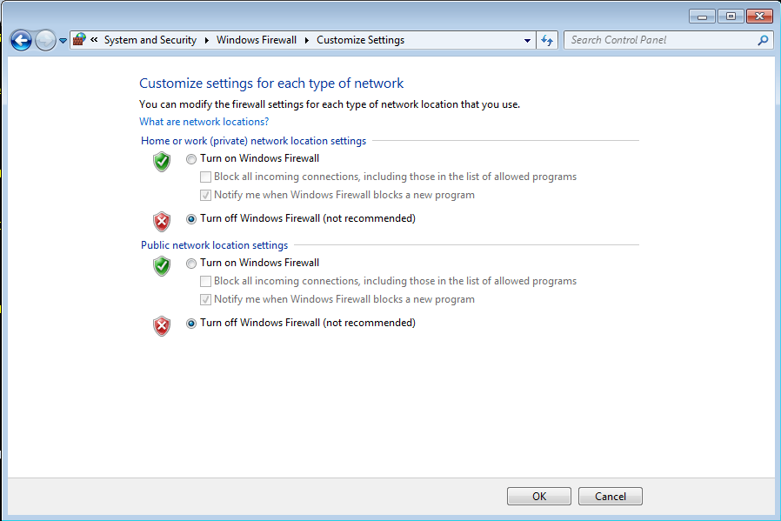
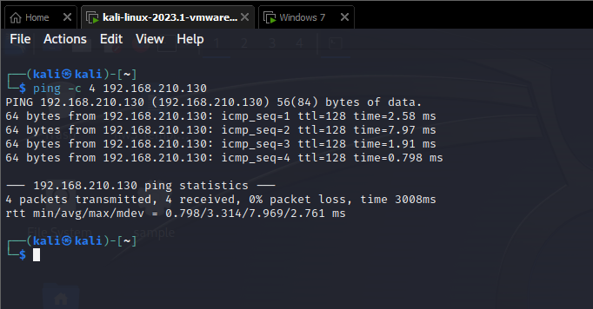
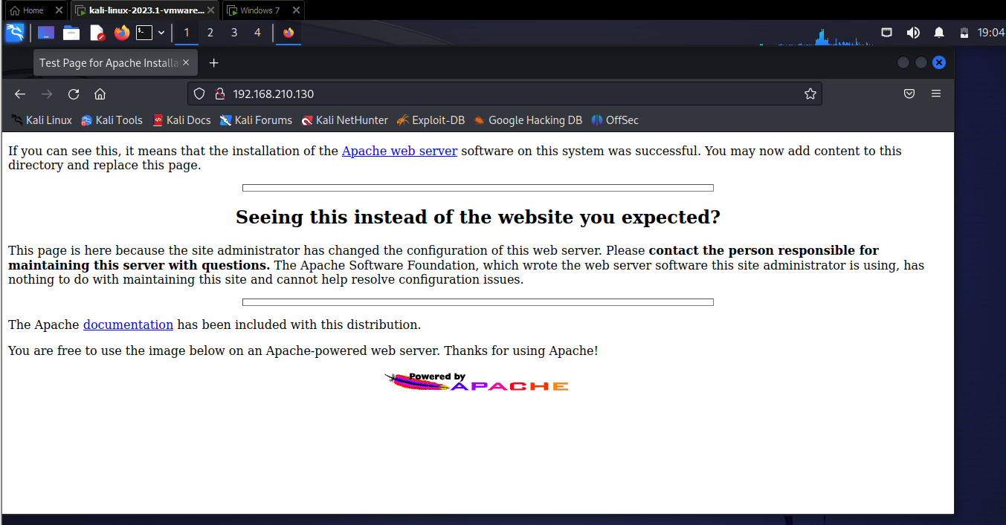
After confirming basic network connectivity, I verified that the Apache web server on the Windows 7 VM was reachable from Kali by browsing to the victim machine’s IP address. The Apache default page loaded successfully, confirming that the target service was running and accessible over the network. This step was important because the exploit attempts depend on the Apache service and its vulnerable weblogic component being active before malformed requests are sent.

Phase 2: Debugger Attachment and Module Discovery
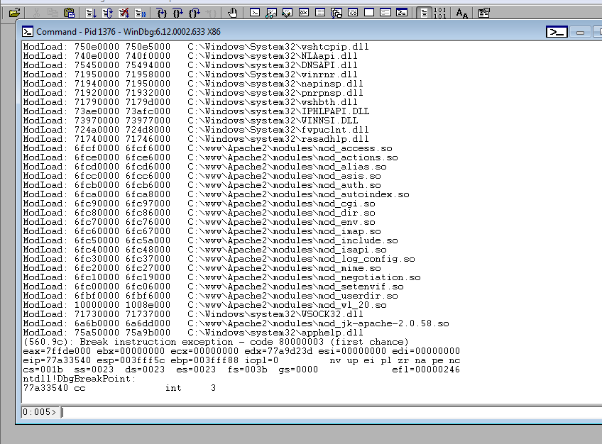
I began the exploitation process by attaching the WinDbg debugger to the active Apache child process. This attachment allows me to monitor the program’s memory and register states in real-time as it processes incoming network traffic. After the debugger was attached and the initial breakpoint was hit, I examined the loaded modules to locate the specific component responsible for the vulnerability: mod_wl_20.so. I identified that this module was loaded at the base memory address of 10000000. Locating this base address is a critical first step, as any jump instructions or memory offsets I use later in the exploit must be calculated relative to where this module sits in the victim's memory.
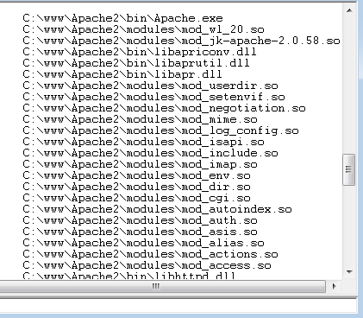

Phase 3: Proof of Concept Crash
To confirm that the Apache service was indeed vulnerable to a stack-based buffer overflow, I conducted a "fuzzing" test by sending a large, uniform payload of "A" characters to the /weblogic/ endpoint. In computer memory, the character "A" is represented by the hexadecimal value 41. Upon sending this payload, the Apache process immediately crashed with an Access Violation (code c0000005). When I inspected the CPU registers, I observed that the $EIP$ (Instruction Pointer) – which acts as the computer's roadmap by telling the CPU what instruction to execute next – had been completely overwritten with 41414141. This result provided definitive proof that I had successfully hijacked the program's execution flow and could now control what instructions the processor runs.
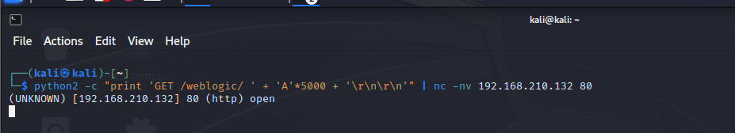
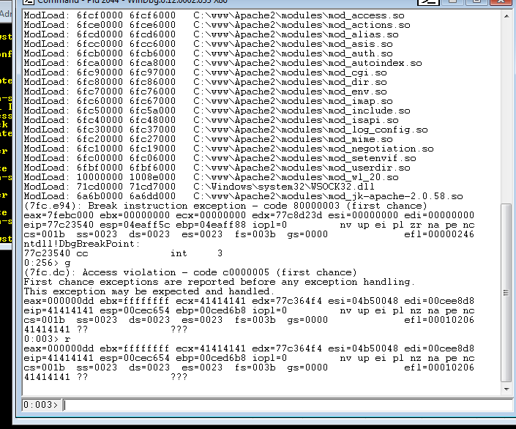

Phase 4: Mitigations and Security Boundary Analysis
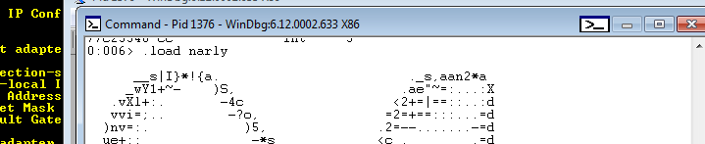
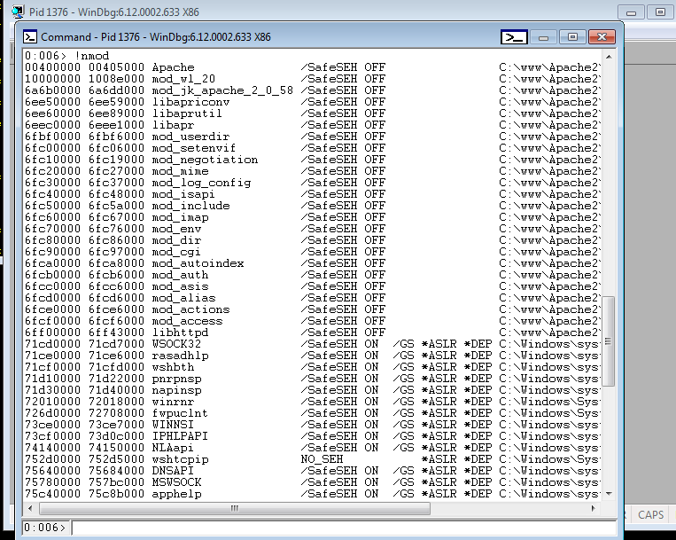
Before I could refine the exploit, I had to determine if any modern security protections were in place that might prevent a standard buffer overflow. I utilized a WinDbg extension called Narly by running the .load narly command. I then used the !nmod command to audit the security features of the loaded modules. My analysis focused on SafeSEH and ASLR (Address Space Layout Randomization), which are designed to make memory addresses unpredictable or block unauthorized "jumps." I confirmed that the target module, mod_wl_20.so, had SafeSEH OFF and ASLR OFF. This lack of protection is a significant security weakness, as it allows me to use hardcoded memory addresses for my exploit with high reliability.

Phase 5: Precision Offset Discovery
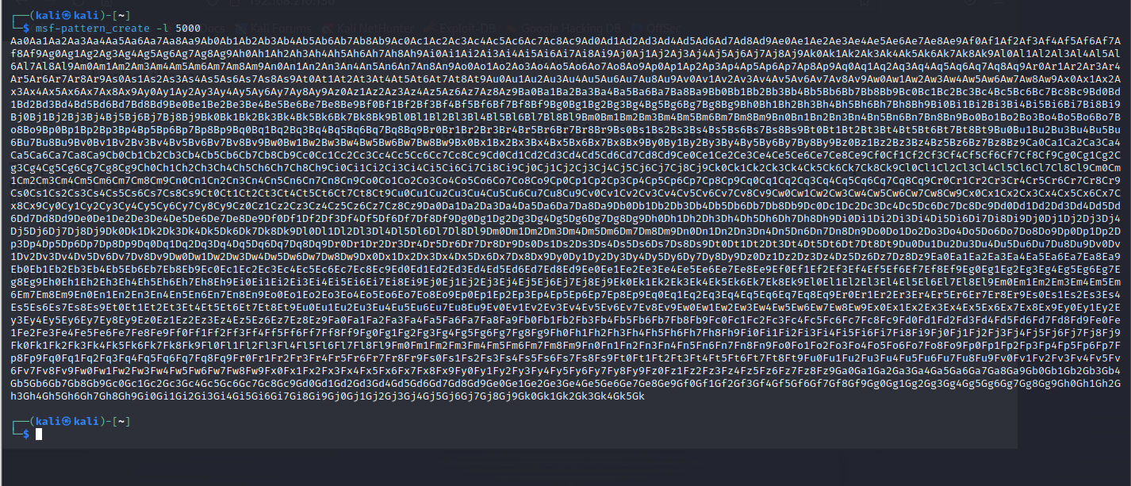
I utilized the msf-pattern_create tool from the Metasploit framework to generate a 5,000-byte cyclic string. Unlike a uniform string of "A" characters, this pattern consists of unique four-byte sequences that never repeat within the string. I generated this specific pattern because it acts as a "GPS" for the computer's memory; if I can crash the server using this string, the unique value remaining in the instruction pointer will allow me to pinpoint the exact byte that caused the crash, rather than just knowing that a crash occurred somewhere in a sea of identical "A"s.

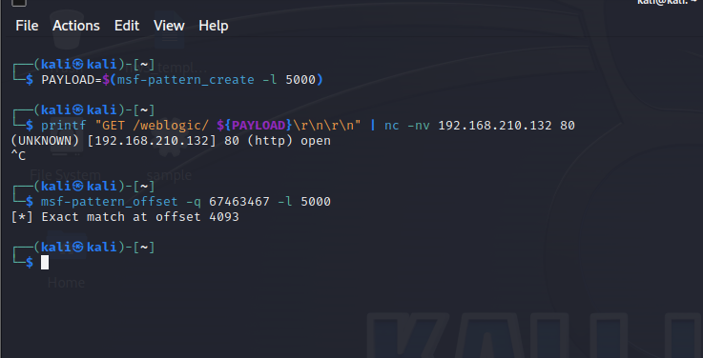
By executing the commands above, I combined the generation of the unique pattern with the delivery mechanism using Netcat. This action is the direct cause of the Access Violation seen in the debugger because it pushed the cyclic data through the vulnerable /weblogic/ endpoint until it successfully overwrote the instruction pointer with a unique number.

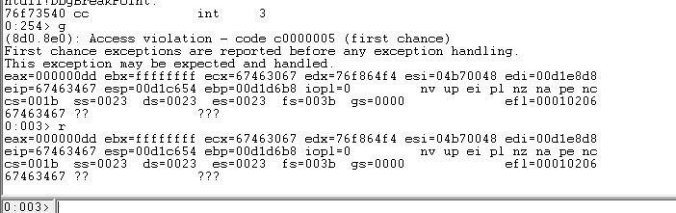
After sending the cyclic pattern to the victim machine, I monitored the resulting crash in WinDbg. The debugger caught a first-chance Access Violation, indicating the Apache process was forced to stop because it attempted to execute an invalid instruction. If I saw that the debugger was still displaying “BUSY…” I would know that the crash failed and would need to try again.
Upon inspecting the registers with the ‘r’ command, I found that the $EIP$ (Instruction Pointer) – the register that tells the CPU where to go next – now contained the value 67463467. This value represents four specific, non-repeating characters from the cyclic pattern that successfully "smashed" the stack and took over the instruction pointer.
I took the hexadecimal value 67463467 found in the $EIP$ and processed it through the msf-pattern_offset tool in my Kali Linux terminal. By querying this unique code against the original 5,000-byte pattern, the tool identified an exact match at offset 4093. This finding is the most critical technical measurement of the entire exploitation process so far; it tells me that I must provide exactly 4,093 bytes of padding data before I can place my own specific memory addresses to take surgical control of the server's execution flow.


Phase 6: Offset Verification and Instruction Pointer Control
With the calculated offset of 4,093 bytes, I moved to verify that I possessed exact control over the processor's execution flow. In my Kali Linux terminal, I crafted a targeted payload consisting of 4,093 "A" characters to fill the buffer, followed by four "B" characters (0x42) intended to overwrite the instruction pointer, and 100 "C" characters (0x43) to serve as a placeholder for my future shellcode.
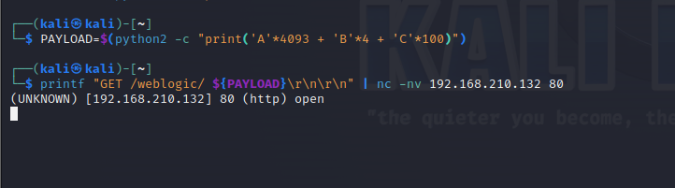
After delivering this payload via Netcat to the target at 192.168.210.132, I monitored the service in WinDbg. The resulting crash confirmed my calculations were 100% accurate; the $EIP$ (Instruction Pointer) was successfully overwritten with 42424242, the hexadecimal representation of my "B" characters. This verification proved that I had bypassed the generic "crashing" phase and now had the ability to redirect the CPU to any memory address of my choosing
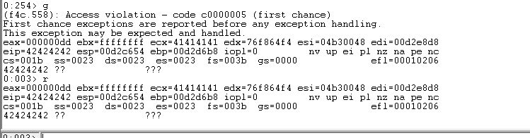

Phase 7: Trampoline Discovery and Jump Verification
Once I verified control over the $EIP$, my next objective was to find a way to redirect the CPU's attention to the stack where my "C" characters – and eventually my shellcode – were residing. I utilized the WinDbg search command s -b 10000000 L 8e000 ff e4 to scan the memory of the mod_wl_20.so module for the machine code ff e4, which corresponds to the JMP ESP instruction.
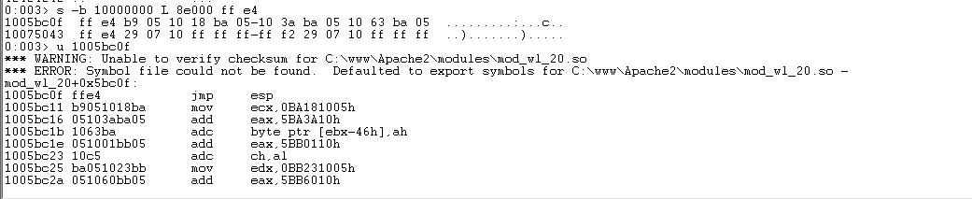
This search identified a potential "trampoline" address at 1005bc0f. To ensure this address was reliable and did not contain "bad characters" like null bytes that would terminate my payload prematurely, I used the u 1005bc0f (unassemble) command. The debugger confirmed that this specific memory location contained a clean jmp esp instruction. By placing this address into the $EIP$ in my final exploit, I can force the CPU to "bounce" off this location and immediately begin executing whatever data I have placed on the stack, effectively turning a simple crash into a functional execution path.

Phase 8: Final Verification of Code Execution
In the final stage of my analysis, I conducted a test to prove that I could not only hijack the execution flow but also execute arbitrary instructions residing on the stack.
To deliver the final exploit payload, I utilized a command-line pipe to redirect the standard output (stdout) of a Python 2 execution into the standard input (stdin) of the Netcat (nc) utility. This method is technically essential for this exploit because manually entering the payload or using a standard echo command could result in the "mangling" of non-printable hexadecimal characters. By using this redirection, I ensured that the raw binary data for the JMP ESP address – specifically the bytes \x0f, \xbc, \x05, and \x10 – were transmitted to the target exactly as intended without being misinterpreted by the shell environment.
The constructed payload follows the specific logic required to trigger the mod_wl_20.so vulnerability:
- Target Request: The command begins with GET /weblogic/ , which directs the traffic to the vulnerable WebLogic component of the Apache server.
- Buffer Padding: I included exactly 4,093 "A" characters, which my previous testing proved is the precise offset required to reach the instruction pointer.
- Execution Hijack: The memory address 1005bc0f is inserted in Little Endian format (\x0f\xbc\x05\x10), which forces the CPU to execute the JMP ESP instruction I identified within the module's memory.
- Verification Payload: I appended 100 "C" characters to provide the CPU with initial instructions once the jump to the stack was complete.
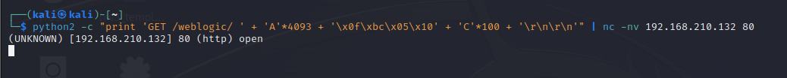

The definitive proof of arbitrary code execution is captured in the final state of the EBX register. In x86 assembly, the character "C" (0x43 in hexadecimal) is interpreted as the INC EBX (Increment EBX) instruction. My payload contained exactly 100 instances of this character to serve as a verification sequence. Upon inspecting the registers after the crash, the EBX register held the value 00000063, which is the hexadecimal equivalent of 99 decimal. This 99-count increment proves with certainty that the CPU successfully followed the JMP ESP trampoline in mod_wl_20.so, landed on the stack, and executed nearly the entire sequence of instructions before the buffer ended. This result confirms the vulnerability allows for reliable instruction processing and is ready for a functional shellcode payload.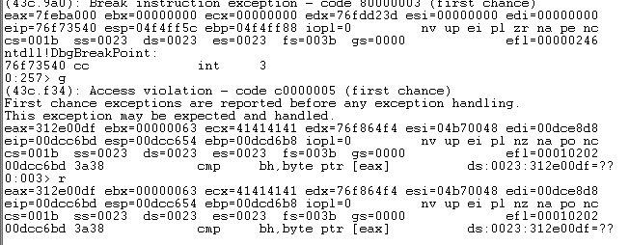

Phase 9: Reverse Shell Payload Generation
To transition from a proof-of-concept to functional exploitation, I utilized msfvenom to generate a Windows-based reverse TCP shell payload. I configured the payload to call back to my Kali attacker IP (192.168.210.128) on port 4444. The command utilized the x86/shikata_ga_nai encoder to generate a 351-byte binary buffer, explicitly excluding the initial "bad characters" \x00, \x0a, \x0d and \x20 to ensure the payload survived transmission through the Apache service. A reverse shell was chosen over a bind shell because it allows the attacker to bypass firewall restrictions by initiating the connection from the victim machine outward, rather than requiring the attacker to connect inbound to a listening service. This screenshot documents the exact raw bytes produced by the framework before they were integrated into the final exploit script.

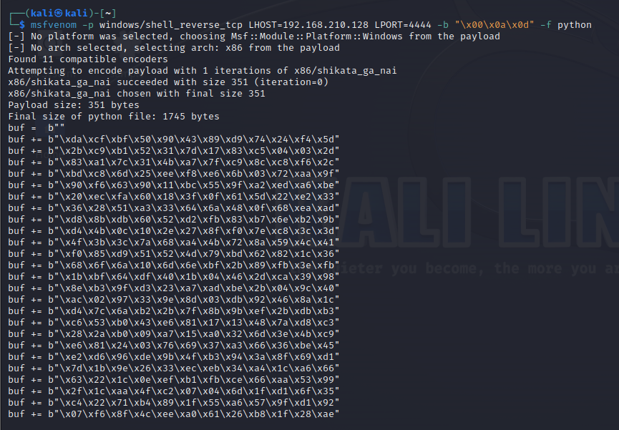

Phase 10: High-Precision Exploit Delivery
To finalize the exploitation process, I utilized a refined Python 2 delivery script designed for bit-perfect binary transmission. This method was critical to avoid the offset shifts and character mangling encountered during previous attempts. I utilized sys.stdout.write to transmit the raw 5,000-byte buffer directly to the Netcat stdin. This payload included the verified 4,093-byte padding, the JMP ESP trampoline address (\x0f\xbc\x05\x10), a 32-byte NOP sled, and the space-scrubbed reverse shell payload. The command targeted the updated victim IP address of 192.168.210.133 on port 80. The terminal output confirmed a successful TCP handshake with the message (UNKNOWN) [192.168.210.133] 80 (http) open, indicating the malicious request was successfully received by the Apache service.
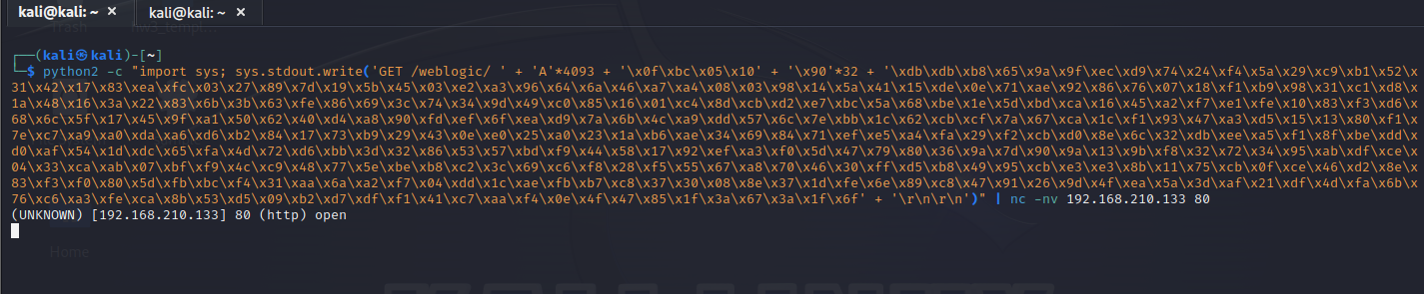

Note: The victim machine's IP address shifted from .132 to .133 during testing due to a DHCP lease renewal; all subsequent commands were updated to reflect this change.

Upon firing the final payload, I monitored the WinDbg session to verify the transition from memory corruption to active code execution. Unlike previous attempts that resulted in an Access Violation at 41414141, the debugger showed a transition through the system calls required to spawn the remote shell thread. The final debugger state showed the $EIP$ at 76e764f4, pointing to a ret (return) instruction within ntdll!KiFastSystemCallRet. This indicates that the initial exploit thread completed its task of launching the shellcode and has returned control to the operating system, while the malicious reverse shell continues to run as a sub-process.
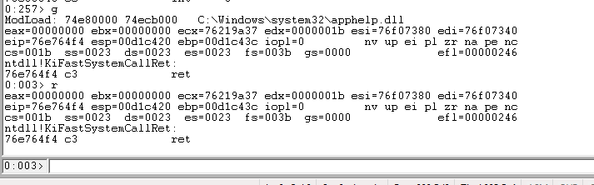
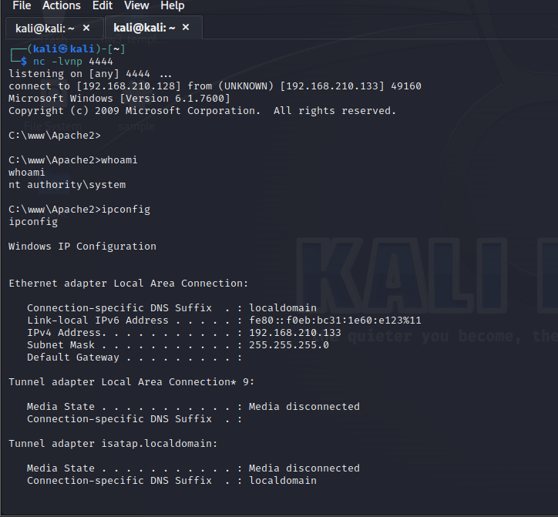
After establishing the reverse shell connection, I executed the whoami command to verify the privilege level of the hijacked process. The output confirmed that the exploit granted me nt authority\system privileges, providing absolute control over the victim operating system. To further validate that the connection was active on the target host, I executed ipconfig, which returned the victim's IP address of 192.168.210.133, providing definitive proof of a successful remote compromise.

Conclusion and Summary
The exploitation of the mod_wl_20.so module on the target Windows 7 system successfully demonstrated the high-impact nature of stack-based buffer overflow vulnerabilities. Through a systematic debugging process, I identified that the Apache service lacked fundamental modern security mitigations, specifically ASLR (Address Space Layout Randomization) and SafeSEH, allowing for the use of reliable, hardcoded memory addresses during the exploitation phase.
Key Technical Findings
- Vulnerability Mechanism: The /weblogic/ endpoint failed to properly validate the length of incoming HTTP requests, allowing a malformed 5,000-byte buffer to overwrite the stack.
- Precision Control: I determined the exact offset to the Instruction Pointer (EIP) to be 4,093 bytes, granting surgical control over the CPU's execution flow.
- Execution Hijack: By utilizing a JMP ESP trampoline located at 1005bc0f, I redirected the processor to a 32-byte NOP sled followed by custom shellcode residing in memory.
- Privilege Escalation: The resulting reverse shell connection granted absolute nt authority\system privileges, the highest level of access available on the Windows operating system.
Final Assessment
This lab confirms that legacy modules and unpatched services represent a critical risk to organizational security. The ability to achieve Remote Code Execution through a single unauthenticated network request highlights the necessity of "Defense in Depth" strategies. To mitigate this specific threat, it is recommended to update the mod_wl_20.so module to a patched version, enable operating-system-level protections like DEP (Data Execution Prevention), and implement strict input validation at the application layer.
The successful establishment of the reverse shell and subsequent verification of system-level access marks the successful completion of all lab objectives.

